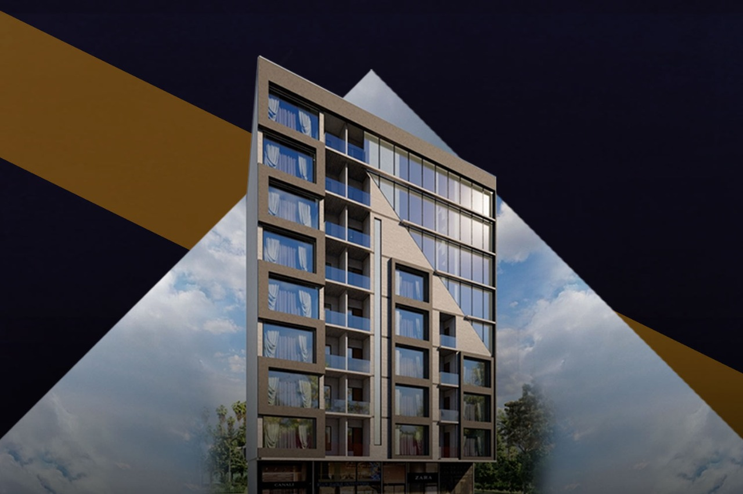
Dx Smart Apartments Payment Plan
Ground Floor Showrooms Payment Plan:
SIZE | Covered Area | Total Price | Down Payment | Site Execution | 30 Monthly Installments
450 sqft. | 450 sqft. | PKR 15,750,000 | PKR 3,937,500 | PKR 3,150,000 | PKR 360,937

2 Bedrooms Payment Plan:
SIZE | Down Payment | On Digging | 30 Monthly Installments | On Completion | Total Payment
800 sqft. | 1,440,000 | 1080,500 | 127,500 | 500,000 | 7,200,000
950 sqft. | 1,719,000 | 1289,000 | 169,600 | 500,000 | 8,595,000

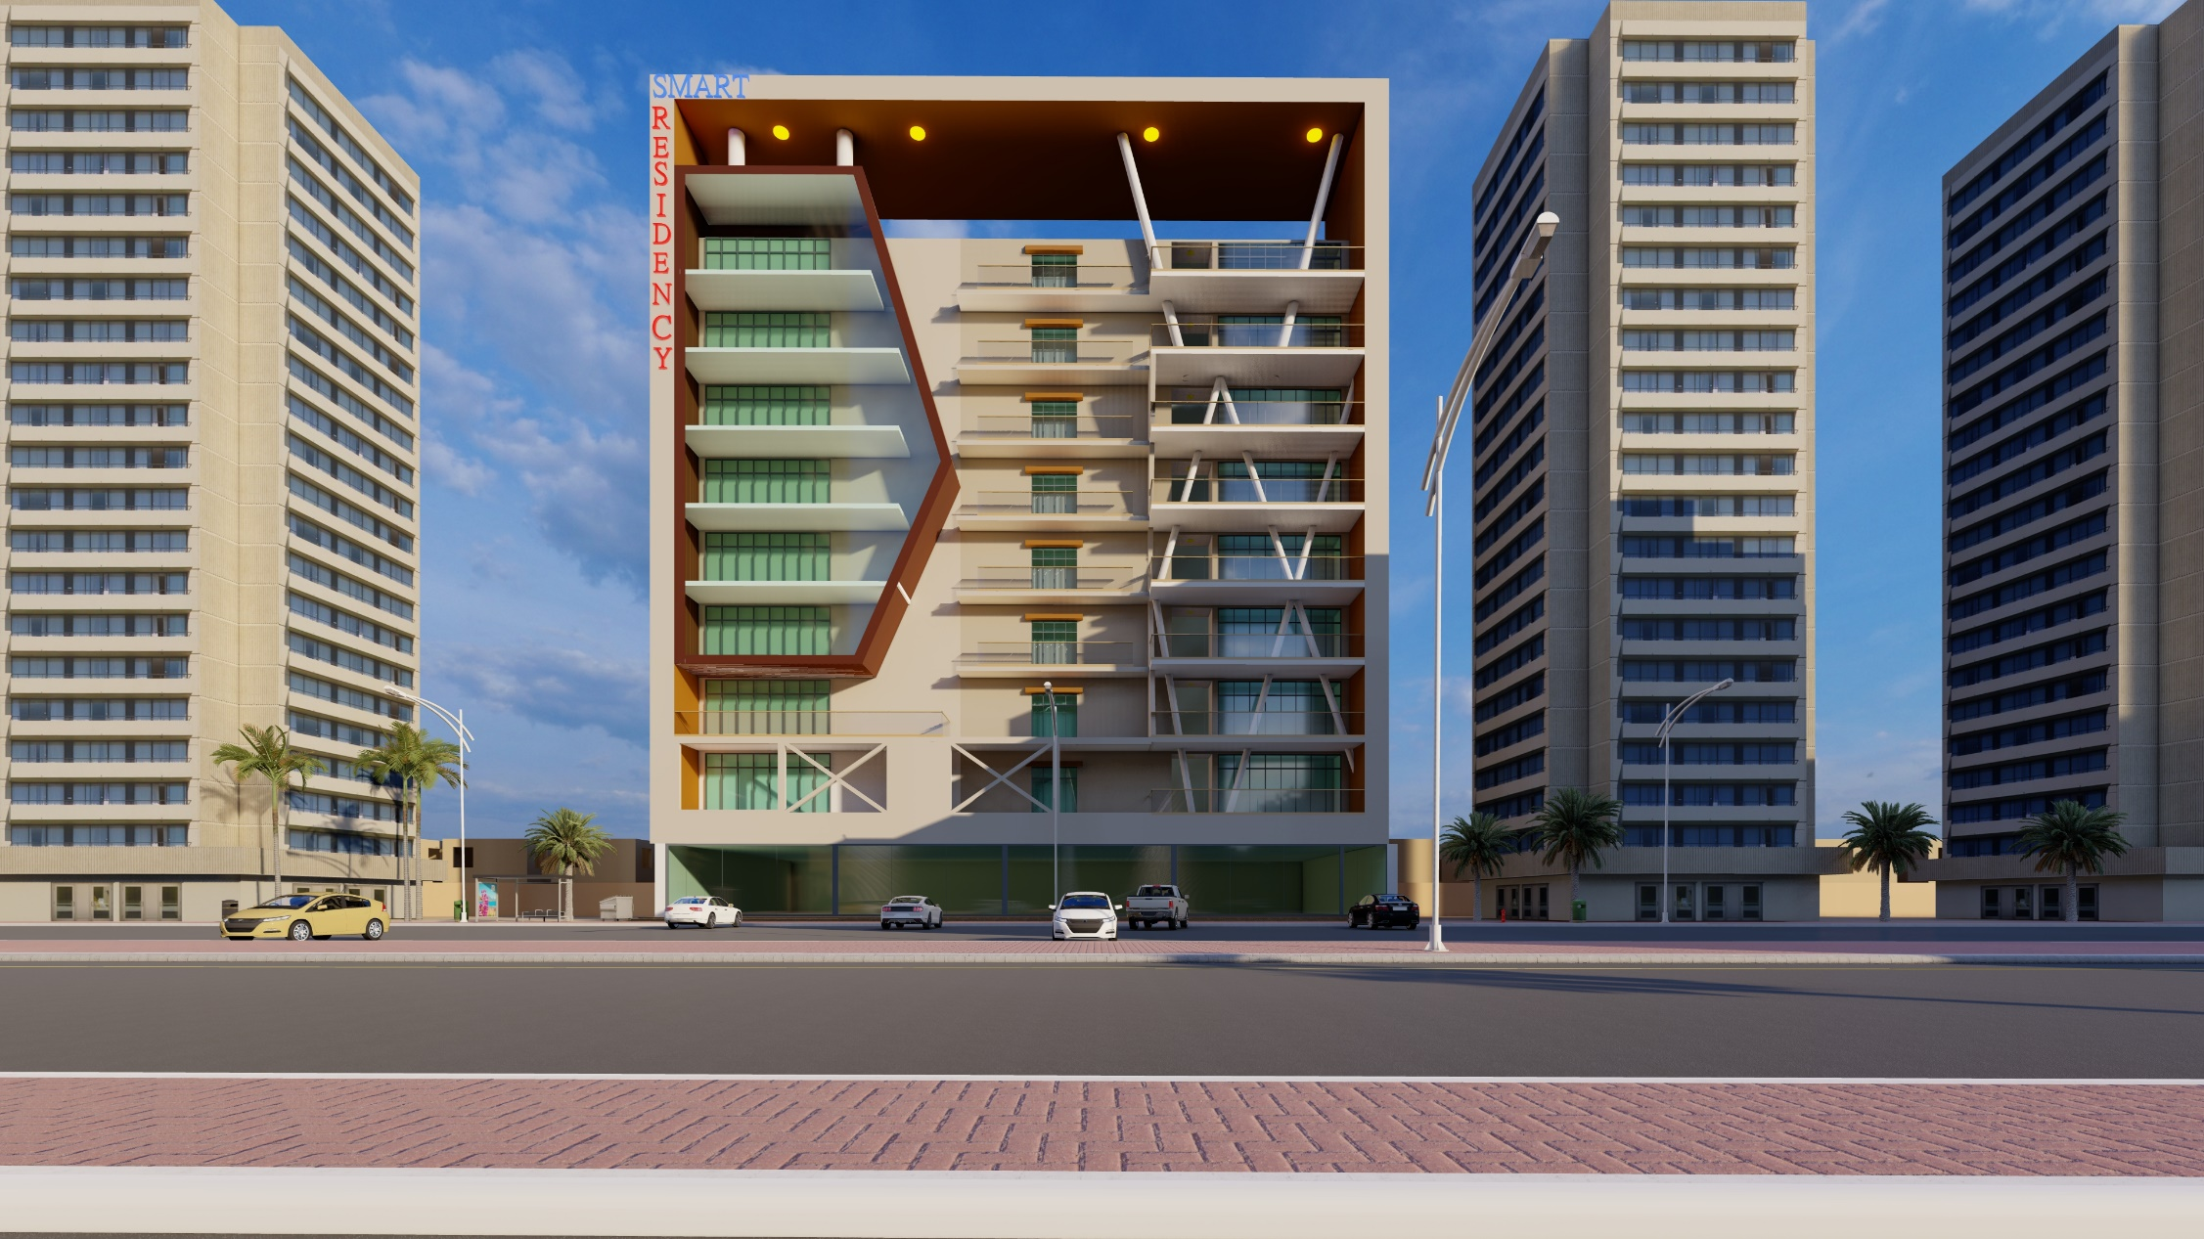
Dx Smart Residency Payment Plan
SIZE | Covered Area | Total Price | Booking 25% | Digging 20% | 30 Monthly Installments
450 sqft. | 450 sqft. | PKR 15,750,000 | PKR 3,937,500 | PKR 3,150,000 | PKR 360,937
Ground Floor Showrooms Payment Plan:

2 Bedrooms Payment Plan:
SIZE | Booking 25% | Digging 20% | 30 Monthly Installments | Total Payment
750 sqft. | 1,593,750 | 1,275,000 | 116,815 | 6,375,000
950 sqft. | 2,018,750 | 1,615,000 | 148,041 | 8,075,000

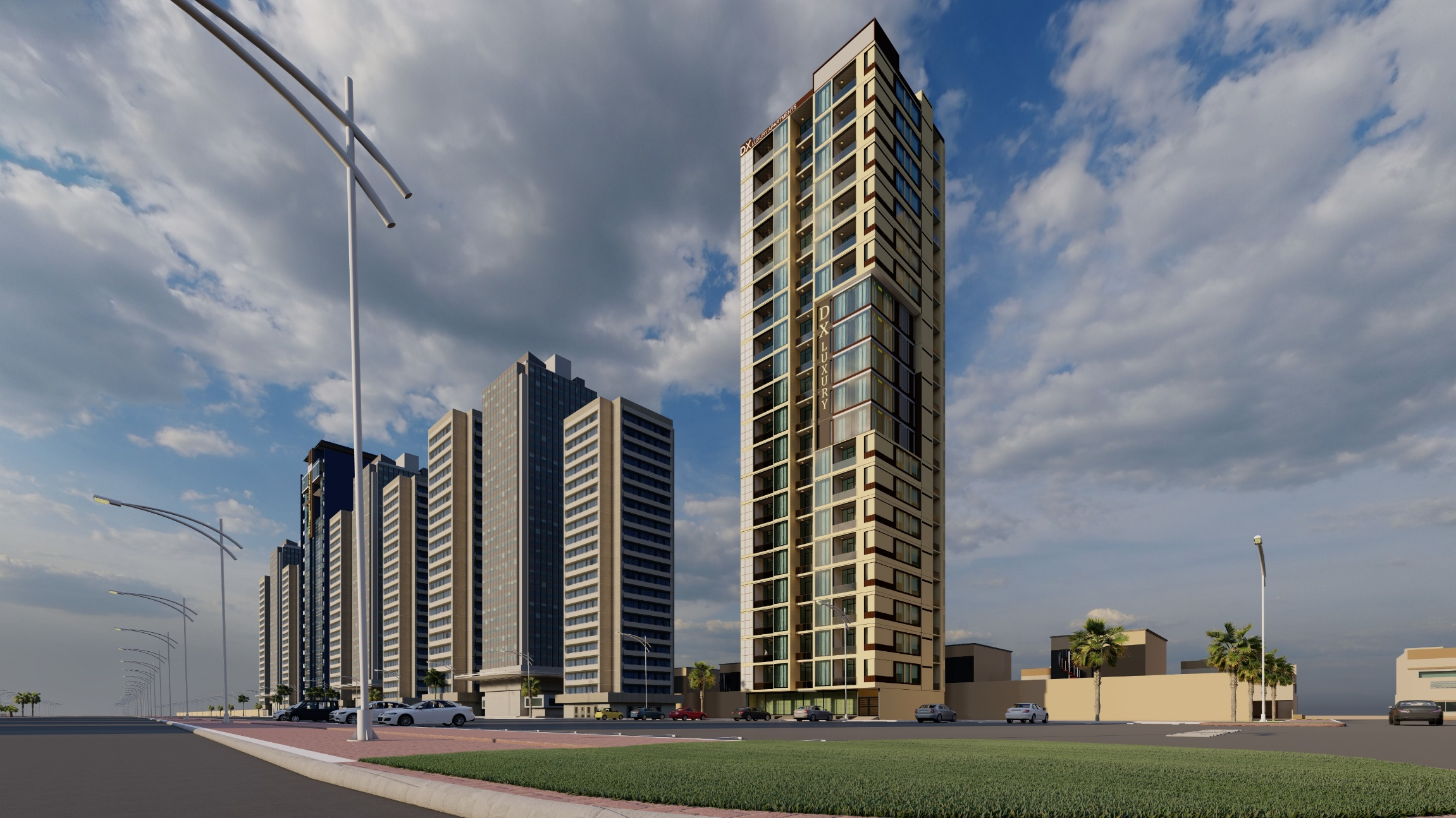
Dx Luxury Apartments Payment Plan
2 DD Bedrooms Payment Plan:
SIZE | Covered Area | Total Price | Down Payment | Site Execution | 30 Monthly Installments
2 Bed | 1000 sq ft. | PKR 12,500,000 | PKR 3,125,000 | PKR 1,875,000 | PKR 250,000
2 Bed | 1030 sq ft. | PKR 14,420,000 | PKR 3,605,000 | PKR 2,163,000 | PKR 288,400
2 Bed | 1085 sq ft. | PKR 15,190,000 | PKR 3,797,500 | PKR 2,278,500 | PKR 303,800
3 DD Bedrooms Payment Plan:
SIZE | Covered Area | Total Price | Down Payment | Site Execution | 30 Monthly Installments
3 Bed | 1565 sq ft. | 19,562,500 | PKR 4,890,625 | PKR 2,934,375 | PKR 391,250
3 Bed | 1765 sq ft. | 24,710,000 | PKR 6,177,500 | PKR 3,706,500 | PKR 494,200

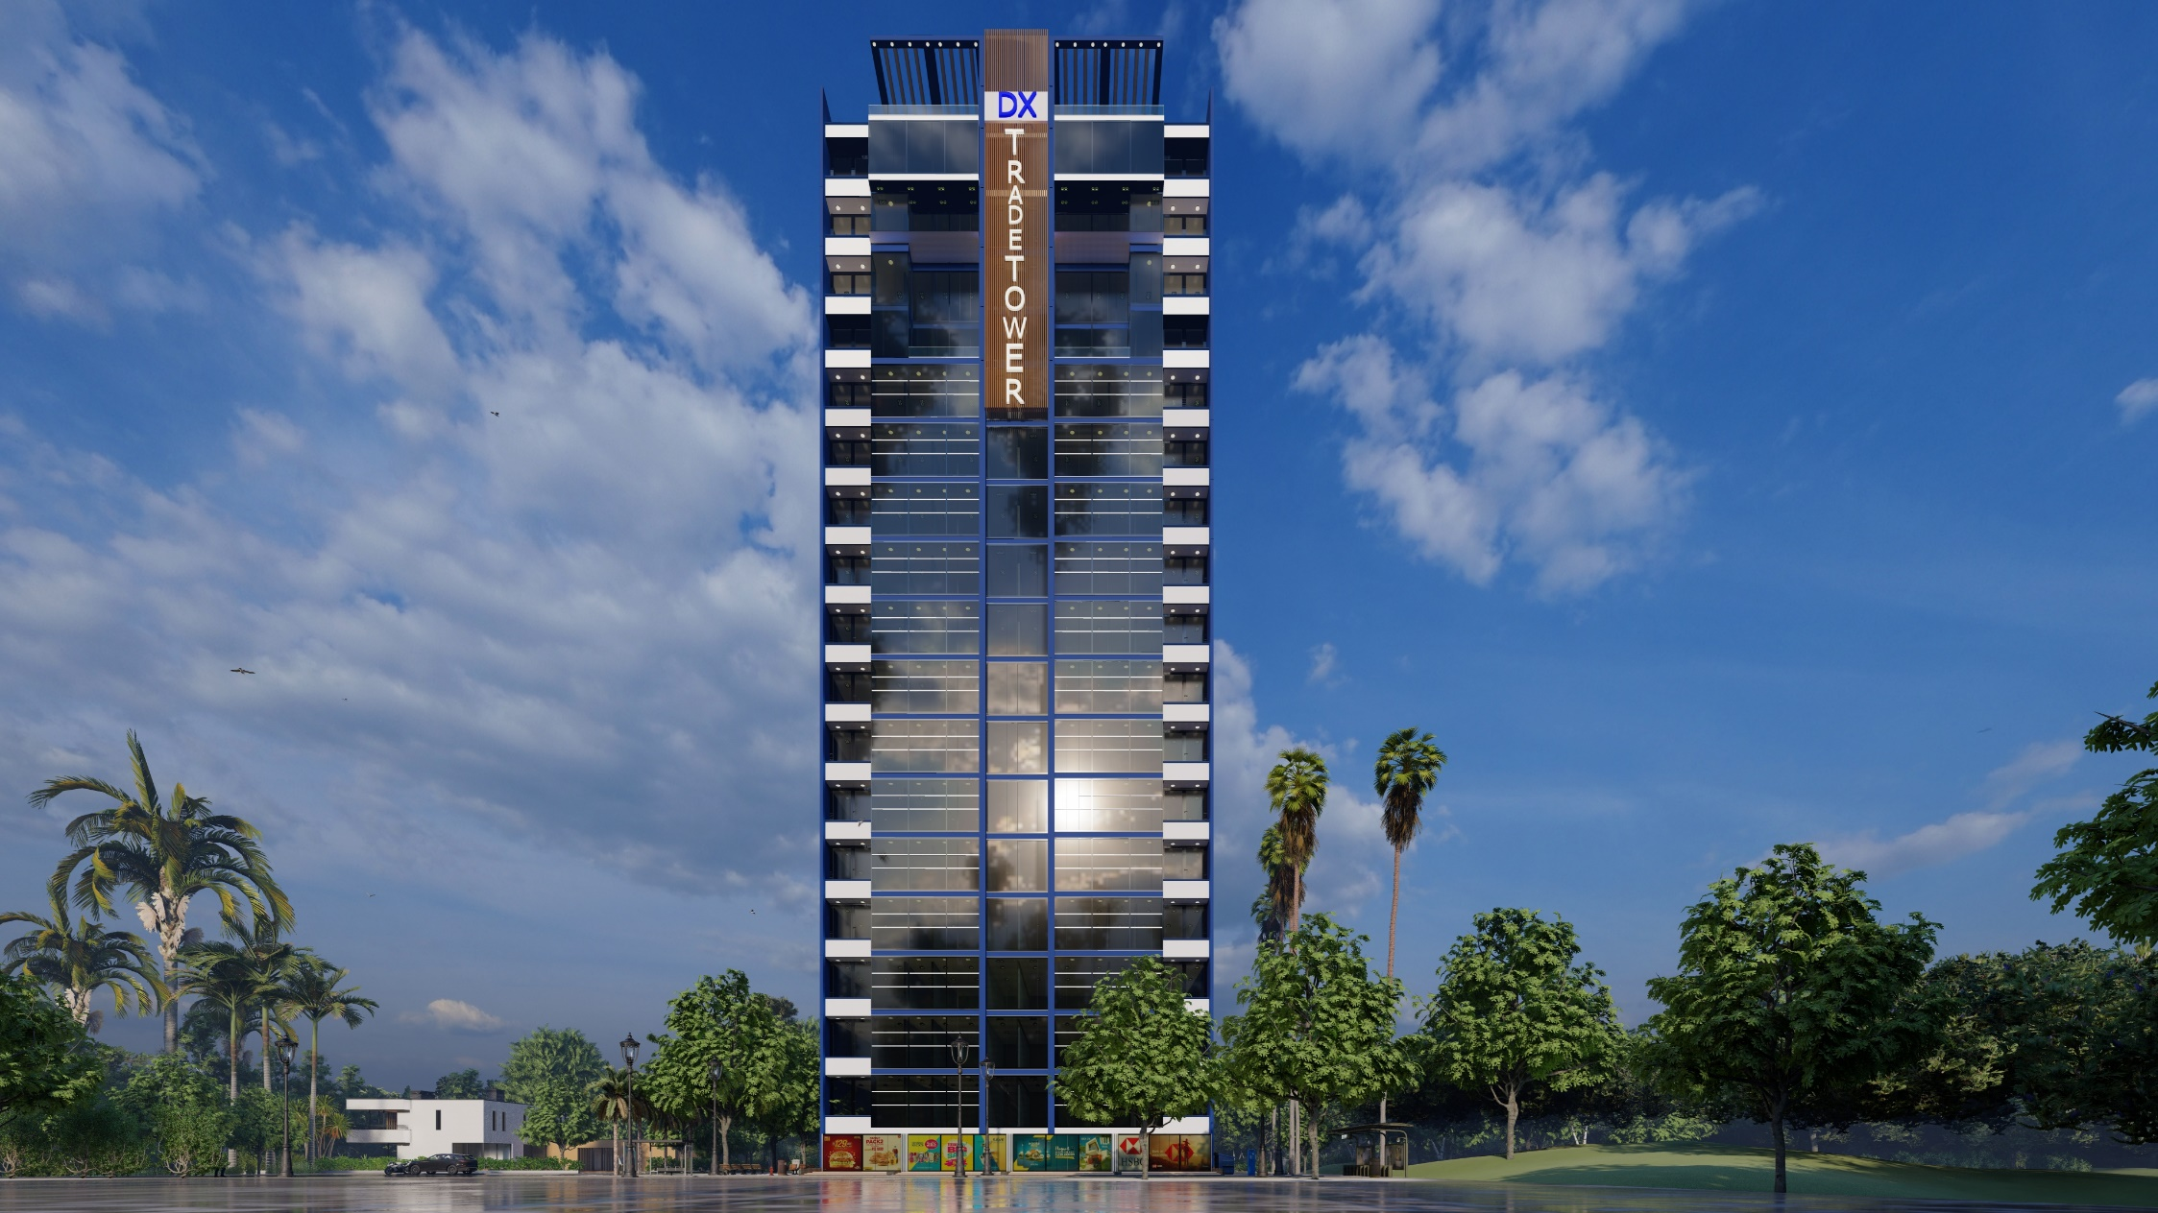
Dx Trade Tower Payment Plan
Floor | SIZE | Rate per sqft. | Down Payment 30% | Site Execution 25% | Site Execution | 30 Monthly Installments
Ground | 1165.17 sqft. | PKR 100,000 | PKR 34,955,100 | PKR 29,129,150 | PKR 2,097,306 | PKR 116,517,000
Ground | 1094.31 sqft. | PKR 100,000 | PKR 32,829,300 | PKR 27,357,750 | PKR 1,969,758 | PKR 109,431,000
Ground | 770.29 sqft. | PKR 100,000 | PKR 23,108,700 | PKR 19,257,250 | PKR 1,386,522 | PKR 77,029,000
Ground | 731.85 sqft. | PKR 100,000 | PKR 21,955,500 | PKR 18,296,250 | PKR 1,317,330 | PKR 73,185,150
1st | 885.88 sqft.  697.82 sqft.  668.46 sqft.  1074.51 sqft.  526.33 sqft.  700.00 sqft. | PKR 16,000 | PKR 3,543,520  PKR 2,791,280  PKR 2,673,840  PKR 4,298,040  PKR 2,105,320  PKR 2,800,000 | PKR 2,834,816  PKR 2,233,024  PKR 2,139,072  PKR 3,438,432  PKR 1,684,256  PKR 2,240,000 | PKR 311,830  PKR 245,633  PKR 235,298  PKR 378,228  PKR 185,268  PKR 246,400 | PKR 14,174,080  PKR 11,165,120  PKR 10,695,360  PKR 17,192,160  PKR 8,421,280  PKR 11,200,000
2nd | 885.88 sqft.  697.82 sqft.  668.46 sqft.  1074.51 sqft.  526.33 sqft.  700.00 sqft. | PKR 14,000 | PKR 3,100,580  PKR 2,442,370  PKR 2,339,610  PKR 3,760,785  PKR 1,842,155  PKR 2,450,000 | PKR 2,480,464  PKR 1,953,896  PKR 1,871,688  PKR 3,008,628  PKR 1,473,724  PKR 1,960,000 | PKR 311,830  PKR 245,633  PKR 235,298  PKR 378,228  PKR 185,268  PKR 246,400 | PKR 12,402,320  PKR 9,769,480  PKR 9,358,440  PKR 15,043,140  PKR 7,368,620  PKR 9,800,000
3rd | 885.88 sqft.  697.82 sqft.  668.46 sqft.  1074.51 sqft.  526.33 sqft.  700.00 sqft. | PKR 13,000 | PKR 2,879,110  PKR 2,267,915  PKR 2,172,495  PKR 3,492,158  PKR 1,710,573  PKR 2,275,000 | PKR 2,303,288  PKR 1,814,332  PKR 1,737,996  PKR 2,793,726  PKR 1,368,458  PKR 1,820,000 | PKR 253,362  PKR 199,577  PKR 191,180  PKR 371,310  PKR 150,530  PKR 200,200 | PKR 11,516,440  PKR 9,071,660  PKR 8,689,980  PKR 13,968,630  PKR 6,842,290  PKR 9,100,000
4th to 18th | 885.88 sqft.  697.82 sqft.  668.46 sqft.  1074.51 sqft.  526.33 sqft.  700.00 sqft. | PKR 12,500 | PKR 2,768,375  PKR 2,180,688  PKR 2,088,938  PKR 3,357,844  PKR 1,644,781  PKR 2,187,500 | PKR 2,214,700  PKR 1,744,550  PKR 1,671,150  PKR 2,686,275  PKR 1,315,825  PKR 1,750,000 | PKR 243,617  PKR 191,901  PKR 183,827  PKR 295,490  PKR 144,741  PKR 192,500 | PKR 11,073,500  PKR 8,722,750  PKR 8,355,750  PKR 13,431,375  PKR 6,579,125  PKR 8,750,000
Showrooms & Offices Payment Plan:

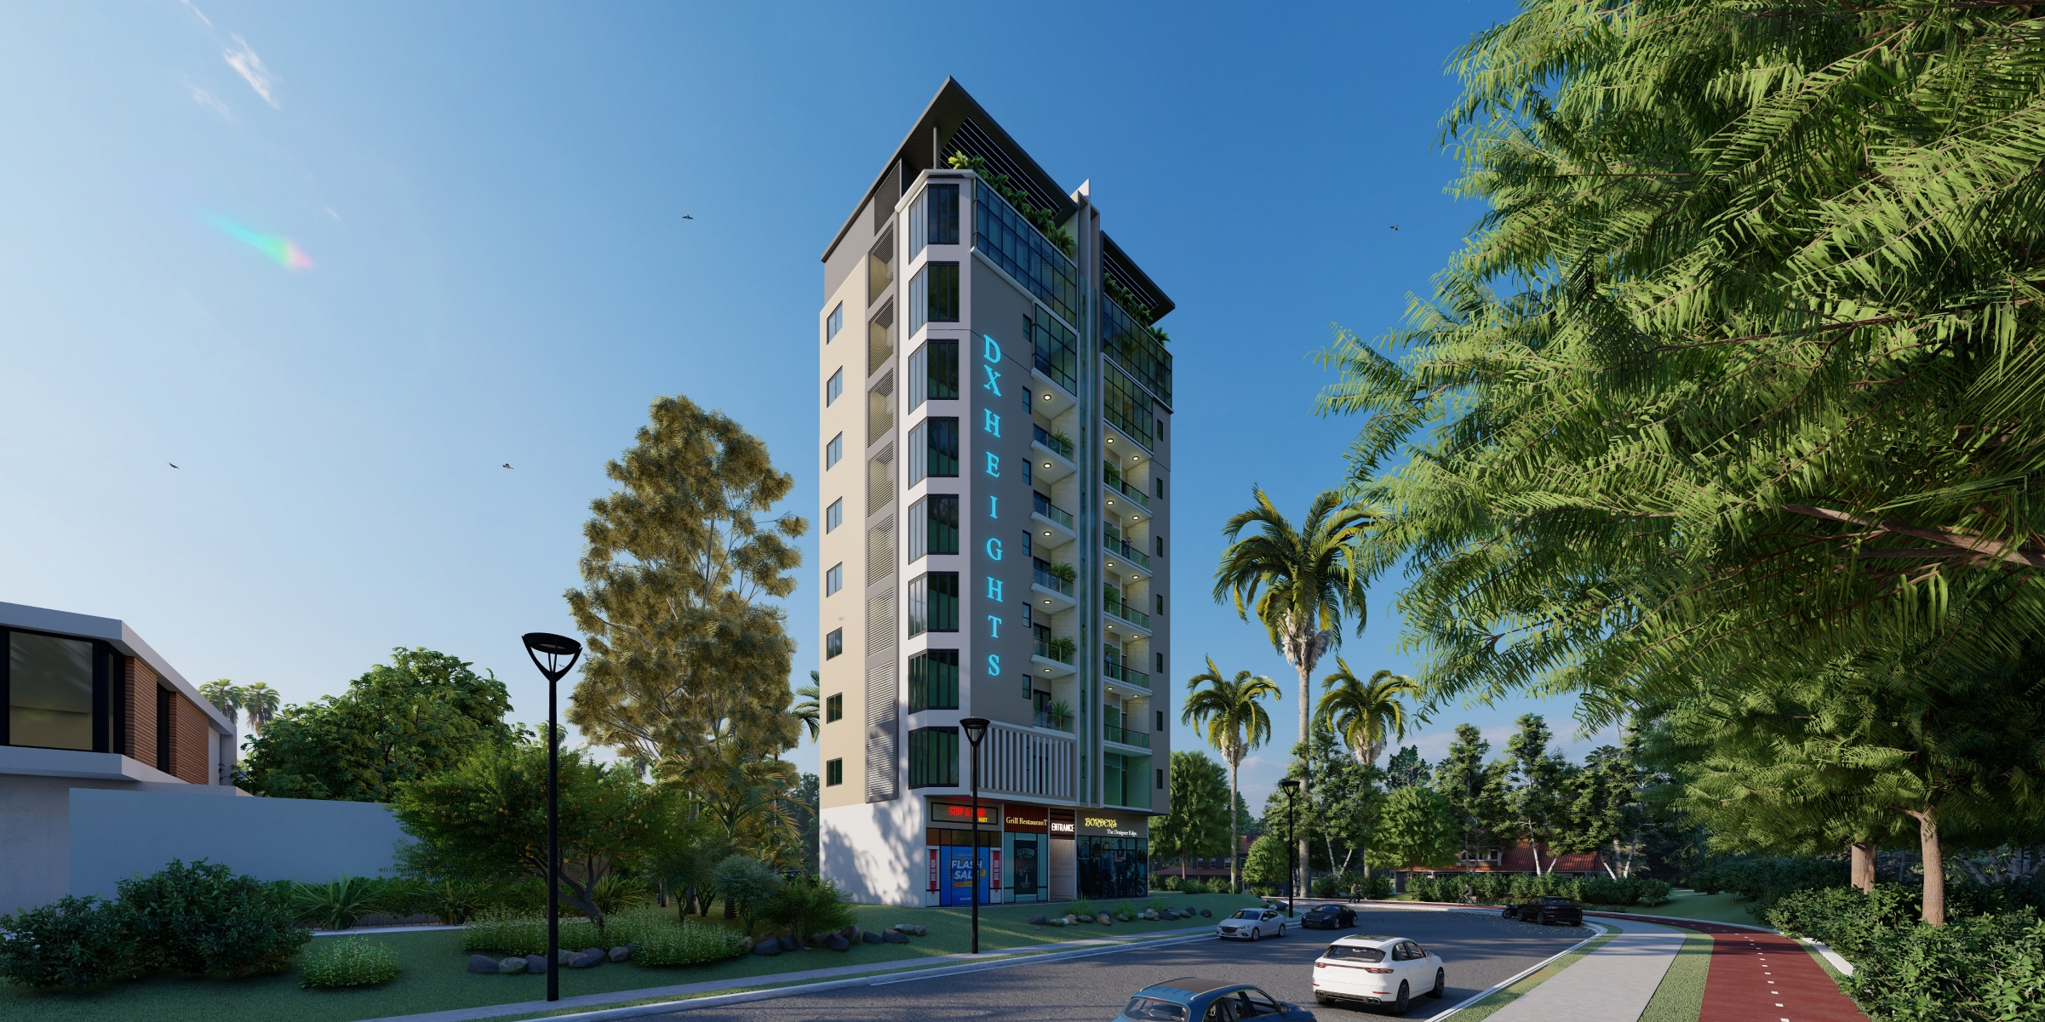
Dx Heights Payment Plan
SIZE | Total Price | Down Payment | Site Execution | 30 Monthly Installments
675 sq ft. | 37,125,000 | 9,281,250 | 7,425,000 | 680,625
475 sq ft. | 26,125,000 | 6,531,250 | 5,225,000 | 478,958
730 sq ft. | 40,150,000 | 10,037,500 | 8,030,000 | 736,083
Ground Floor Showrooms Payment Plan:
2 Bedrooms Payment Plan:
SIZE | Covered Area | Total Price | Down Payment | Site Execution | 30 Monthly Installments
1067 sq ft. | 1067 sq ft. | PKR 11,630,300 | PKR 2,907,575 | PKR 2,326,060 | PKR 213,222
3 Bedrooms Payment Plan:
SIZE | Covered Area | Total Price | Down Payment | Site Execution | 30 Monthly Installments
1530 sq ft. | 1530 sq ft. | PKR 16,677,000 | PKR 4,169,250 | PKR 3,335,400 | PKR 305,745

